**DEVELOPING A CHATBOT**

**Building Chatbot And Integrate To Application**

|  |  |
| --- | --- |
| TEAM ID | PNT2022TMID52257 |
| PROJECT NAME | Smart Fashion Recommender Application |
| TEAM MEMBERS | BABIS DANIA.T, AJISHA.J  AMISHYA RENJAI.R. J, ASPIYA.S |

Building Chatbot

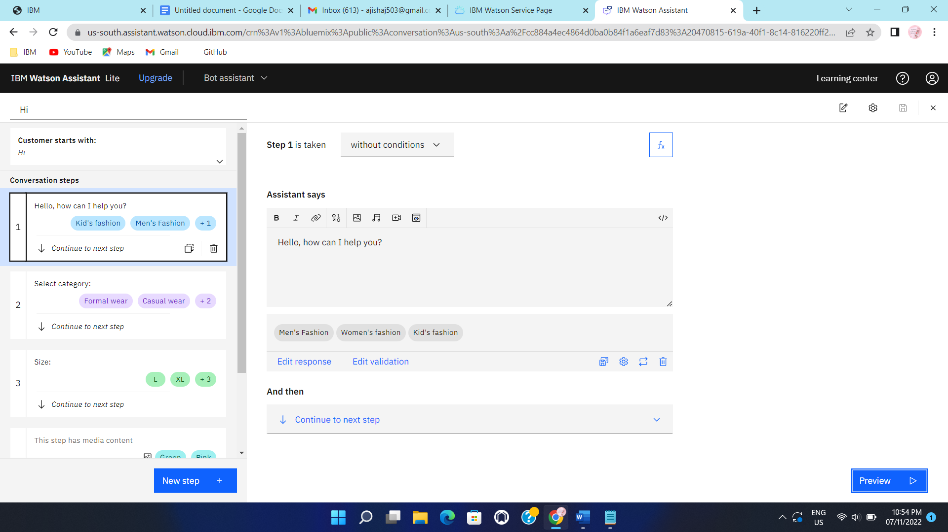

Chatbot Integration

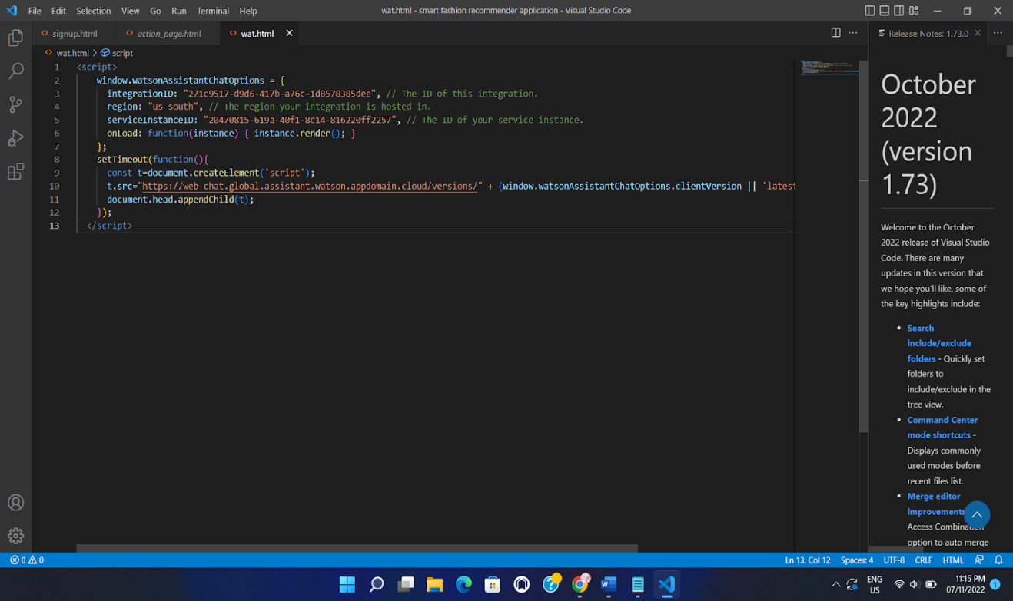

CHATBOT

